|  |  |  |  |  |  |
| --- | --- | --- | --- | --- | --- |
| Date | 13-Dec-22 | | | Tester Name | Richard Belanger |
| Environment | Penfax - Test | | | Login used | TEST2 |
| Operating System | Select OS | Version: | Update: | | |
| Software Used | Select Software | Version: | Update: | | |
| Select Software | Version: | Update: | | |
| Release version | 22.4.1 | | | | |
| Title | M27 Reversal and Adjustment through OLC and DCT | | | | |
| Test Type | Regression | | | | |
| Test Scenario | M27.02 Reverse an Enrolment | | | | |
|  |  | | | | |
| Expected Results | Employee Profile should not be available in Navigation panel.  Member Status should become Inactive. | | | | |
| Pass/Fail | Pass | | | JIRA# | N/A |

Describe your steps with screenshots:

1. Bring up a MEPP member who is recently enrolled and has no contribution posted yet. Note down the vesting service.

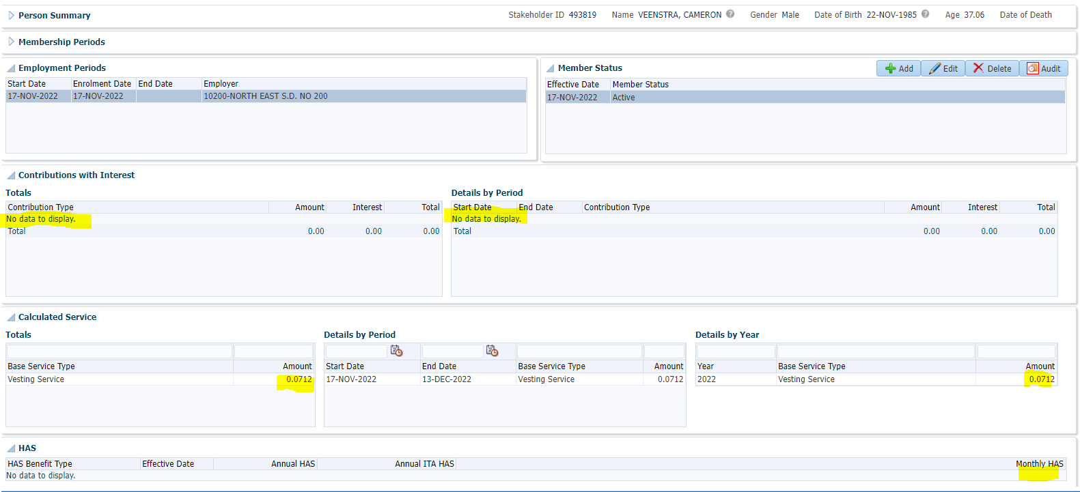

1. Go to Contribution History and Payroll History to check there is no contribution posted yet.

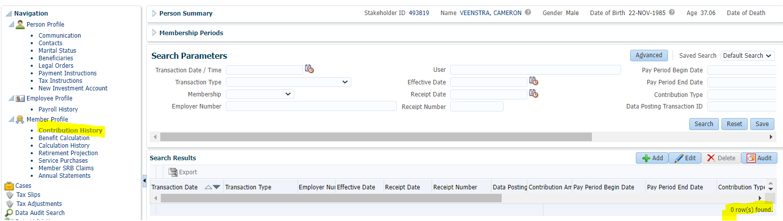

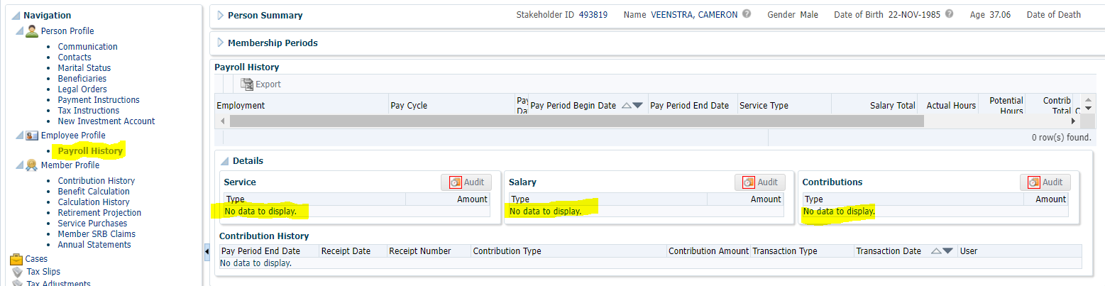

1. Go to Employee Profile. Click Delete under Employment Periods to end the employment.

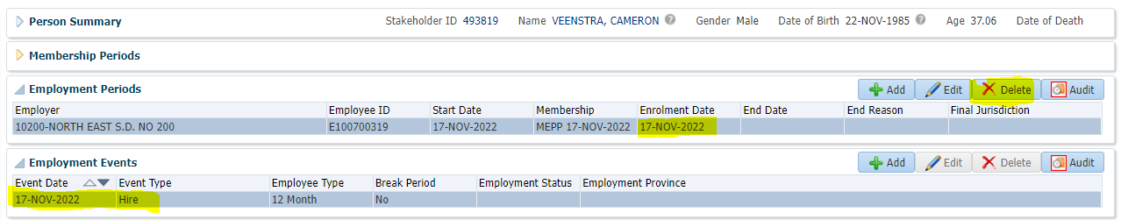

Click Yes.



1. Make sure, on deleting the employment record, Employee Profile is no longer available in Navigation panel.

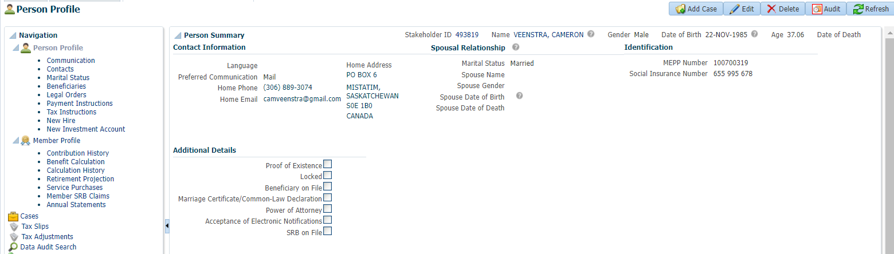

1. Member Profile. Employment Periods and Calculated Service has no data to display.

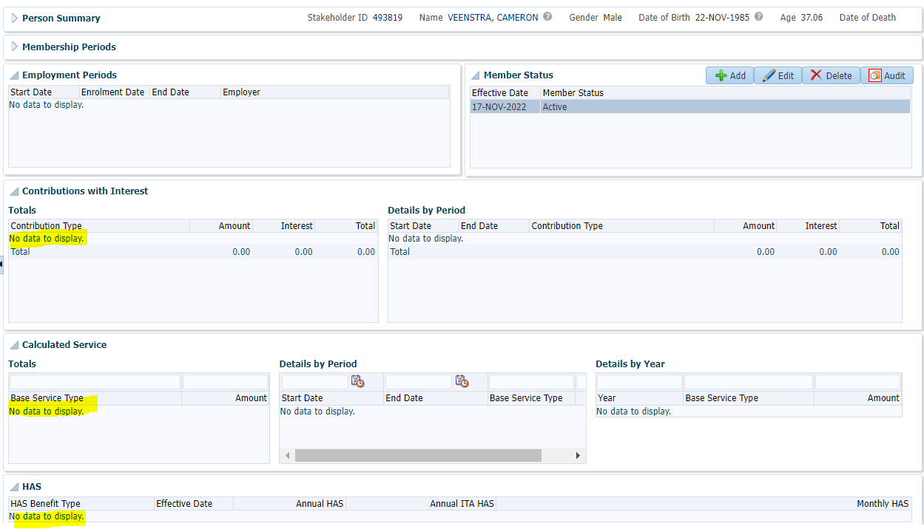

1. Click on Edit as shown in the below screen and select Member Status = Inactive from the dropdown and click on Save to reverse member’s enrolment in MEPP.

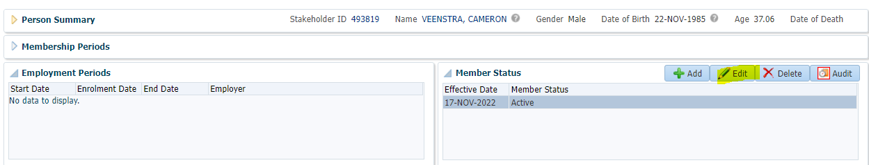

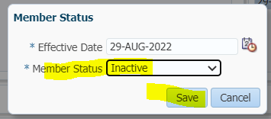

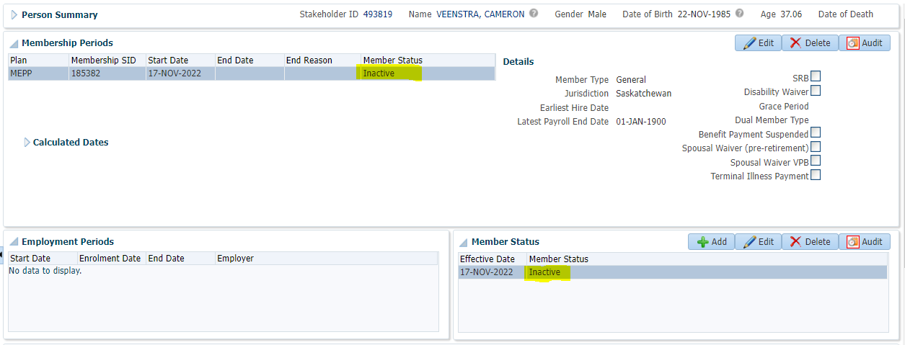

**Note**: If there is contribution posted to member’s account before reversal, follow the procedure described in M27.03 to reverse all the contribution and then follow the above described steps.